# **Résultat de recherche d'images pour "INRA GAFL"**Résultat de recherche d'images pour "INRA Pathologie végétale"**Résultat de recherche d'images pour "sfr tersys"Résultat de recherche d'images pour "INRA Pathologie végétale"**

# **Maintaining plant immunity to pathogens in water stress conditions**

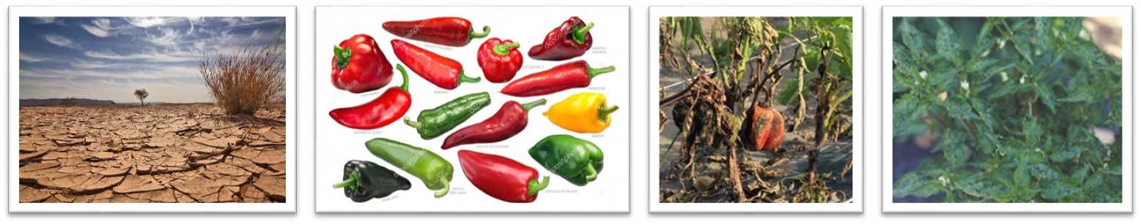

## **Scientific background:**

The stability of agricultural production and therefore food security are threatened by global warming, characterised by a global rise in temperature, an increase in the frequency of extreme events, unstable water regimes and an increase in the geographical range of some pests and pathogens. The immunity of plants to pests and pathogens can be strongly reduced by such abiotic stresses. For farmers, it is desirable that plant immunity to pathogens be maintained in a variety of biotic and abiotic environments representative of the diversity of production conditions in order to keep the yield and quality of plant products as constant as possible. The stability of a trait (immunity or other) under different combinations of biotic and/or abiotic stresses is called robustness and could be determined by specific genes of the organism.

## **Objectives of the internship:**

The internship will be carried out in the context of ongoing research projects that allowed the identification of pepper cultivars with a high or low robustness of immunity to heat treatment. Immunity was studied towards two different pathogens: the virus PVY and the oomycete *Phytophthora capsici*. The pepper genetic regions involved in robustness of immunity have also been identified.

The trainee will have to determine if the robustness of immunity to heat stress also provides robustness of immunity to other stress conditions: (1) water stress (excess or deficit) and (2) coinfection of plants by two pathogens simultaneously. The candidate will therefore have to develop and carry out phenotyping tests to quantify plant immunity and perform statistical analyses of the results. She/he will also measure plant photosynthetic traits in the presence or absence of biotic and/or abiotic stresses and test whether they are related to robustness.

**Research Question**: Are the mechanisms associated with the robustness of pepper immunity under heat stress conditions also effective under water stress conditions or under coinfection?

## **Candidate level:**

M1 or M2, the content of the internship may be adapted to its duration.

## **Skills developed:**

* Quantitative genetics (association genetics)
* Phytopathology (mycology, virology)
* Statistics (R software)
* Analysis of photosynthetic activity
* Experimental design and management
* Molecular biology (qPCR, KASP genotyping, ELISA, …)
* Teamwork
* Scientific communication

## **Laboratories involved:**

* INRAE UR 1052 GAFL (<https://www6.paca.inrae.fr/gafl_eng/>)
* INRAE UR 0407 PV (<https://www6.paca.inrae.fr/pathologie_vegetale_eng/>)
* Avignon Université UMR Qualisud (<https://umr-qualisud.cirad.fr/en>)

## **Location:**

INRAE Domaine Saint Maurice, 64 Allée des Chênes, 84140 Montfavet, France

## **Supervisors:**

* William Billaud (Doctoral student, Avignon Université, INRAE UR 1052 GAFL & UR 0407 PV) <https://www.linkedin.com/in/william-billaud-biologie/?locale=en_US>
* Félicie Lauri (MCF, Avignon Université UMR Qualisud)
* Véronique Lefebvre (DR, INRAE UR 1052 GAFL)
* Judith Hirsch (CR, INRAE UR 0407 PV)
* Benoit Moury (DR, INRAE UR 0407 PV)

## **Contact:**

[william.billaud@inrae.fr](mailto:william.billaud@inrae.fr)

**Ressources:**

* Associated PhD project : <https://www6.paca.inrae.fr/gafl_eng/Partnerships-and-Projects/National-Projects/RobusThese>
* Félix MA, Barkoulas M (2015). Pervasive robustness in biological systems. Nature Reviews Genetics 16, 483.
* Velasquez AC (2018). Plant and pathogen warfare under changing climate conditions. Current Biology 28, 619.
* Tamisier L (2020). Genome-wide association mapping of QTLs implied in potato virus Y population sizes in pepper: evidence for widespread resistance QTL pyramiding. Molecular Plant Pathology 21, 3.
* Mallard S (2013). A key QTL cluster is conserved among accessions and exhibits broad-spectrum resistance to *Phytophthora capsici:* a valuable locus for pepper breeding. Molecular Breeding 32, 349.
* Göhre V (2015). Immune responses: Photosynthetic defence. Nature Plants 1, 15079.